Abstract

Acknowledgements

Figures and Tables

Introduction

Background and Motivation

Research Objective

Project Plan

Literature Review

FSP:

FSP simulation

FSP’s previous visualization research

Satellite:

Orbit type and Height distribution

Kepler element

Coordinate system

Visualization:

Information Visualization

User centered design

Current Space Object Visualizers

Web technology:

Cesium.JS

HTML&CSS&JS

User Research

User research method

Useful

Public Awareness

Methodology

Results

Discussion

Conclusion

# Introduction

## Background and Motivation

Since the late 1990s, technological advancements have facilitated the design of smaller and lighter satellites with improved capabilities. Concurrent improvements in launch technology have broadened access to the space industry, allowing a diverse array of operators to deploy an increasing number of satellites into orbit (Peterson, Sorge and Ailor, 2018). Especially in recent years, commercial investment in space has increased, with multiple commercial companies proposing or funding the deployment of very large constellations of small to medium-sized satellites, leading to a surge in the space population (Muelhaupt *et al.*, 2019).

An analysis of the global number of space objects—including satellites, probes, landers, crewed spacecraft, and space station flight elements launched into Earth's orbit or beyond—reveals a surge from 1810 to 2163 between 2021 and 2022. This increase is noteworthy, considering the average annual number of objects launched into space remained relatively constant at approximately 110 until 2012 (Figure 1).

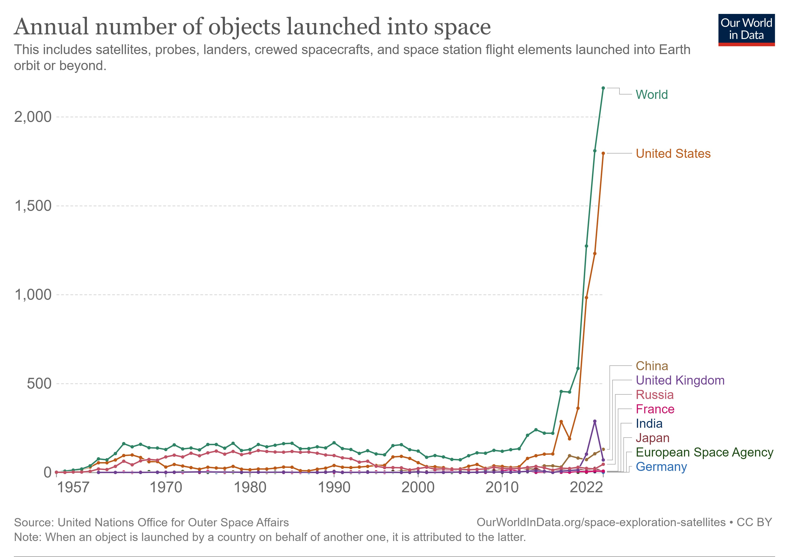

**Figure 1** The annual number of objects launched into space(Our World In Data, 2023).

The exponential increase in the space population has introduced complexities in space operations and amplified the risk of collisions, instigating concerns regarding possible space crowding. Despite International treaties affirming that space should be used for the benefit of all, with nations cooperating to leverage space technology in achieving global development goals, there seems to be a lapse in stringent regulations and management (Kopal, 1966). Countries such as the United States, China, Russia, and Japan have expressed increasing concerns about potential conflict in space, simultaneously escalating their investment in both military and commercial activities in outer space (ZURICH, 2022). The attitude towards the rapidly growing space population is reflected by Elon Musk's remark, "A couple of thousand satellites is nothing. It's like, hey, here's a couple of thousands of cars on Earth, it's nothing" (*BBC News*, 2021).

The evident absence of comprehensive global regulation underscores the urgent need for increased public awareness and international governance, directing the race for space towards collaboration rather than conflict. The visualization of spatial populations can play a crucial role in this effort by translating abstract concepts into tangible, easy-to-understand forms that are accessible to a wider audience, thereby inspiring greater public participation and support for responsible space management (Chen, 2010; Interaction Design Foundation, 2023).

Numerous space object visualizers already exist, such as Leolab's Low Earth Orbit Visualizer and SpaceAware.io, providing insight into past and current space objects, but there is still a gap in the visualization of future space populations.

However, the UCL Future Space Population Study has begun to address this gap. Utilizing the UCL Orbit Dynamics Library (UCL-ODL) (Bhattarai *et al.*, 2019)—a codebase with associated programs and datasets originally designed to study force modelling strategies—the researchers have been able to calculate the positions of space objects for the next +5, +10, +25 years, incorporating both historical satellite data and future launch plans(Bhattarai and Ziebart, 2021).

This research aims to build upon the results of UCL's existing model for future space populations, addressing a gap in space object visualization with a specific focus on future projections. There is already a base visualization tool for future space population (FSP) results, but there is still potential for improvement in the visualization methodology. Therefore, this study will build on the existing base visualization tool to refine and enhance it to provide a more accurate and intuitive representation of future spatial population (FSP) projection data.

## Research Objectives

As stated in the chapter of background and motivation, this research project focuses on the visualization development of FSP results. Therefore, the research objectives are:

* To design a further enhanced FSP Visualizer
  + Identify and rectify the primary limitations and deficiencies in the existing Future Space Population (FSP) visualizer.

*RQ1: What are the main limitations or deficiencies in the existing FSP visualizer?*

*RQ2: How can these limitations or deficiencies be effectively corrected?*

* + Develop an enhanced FSP visualizer tailored for users with no or little knowledge of space objects, aiming to effectively transmit the main results of the FSP simulations.

*RQ3: What are the essential data and information that need to be visualized for users with no or little knowledge of space objects?*

*RQ4: How to implement the principle of visualization to the visualizer to enhance the usability of the FSP visualizer.*

* Evaluate the usefulness of the Design Visualizer by implementing user research.

RQ5: What are the key components and criteria that should be evaluated to assess how useful the newly designed FSP visualizer is?

## Report structure

Chapter 1: This chapter provides an overview of the research project, outlining the primary problem statement and the motivation behind the research.

Chapter 2: This chapter delves into the foundational literature that shapes the project, structured into six critical sections, which are future space population, satellites, visualization, web technology, useful, and the public awareness.

Chapter 3: This chapter offers a concise overview of the methodology employed for the study. The initial section delves into the design and preparation of the prototype, detailing its data structure and anticipated results. Subsequently, the second section outlines the approaches adopted for the user study.

Chapter 4: This chapter reveals the results of the prototype design and user research.

Chapter 5: This chapter will provide a comprehensive analysis and discussion of the findings of the study, incorporating the research objectives and insights from the literature review. In addition, the limitations of the study are discussed in this chapter and directions for future work are suggested.

Chapter 6: The final chapter summarizes the findings in a comprehensive manner by distilling the previous discussion.

# Literature Review

This literature review section provides an overview of the core areas covered. First, it will focus on the future space population (Chapter 2.1) and its related simulation and visualization research. Following this, within the satellite field (Chapter 2.2), this review will explore in depth the orbit elements, orbit types, and coordinate reference systems. Within the visualization section (Chapter 2.3), user-centered design, visualization principles, and current space object visualization tools will be covered. The web technologies section (Chapter 2.4) covers Cesium.js technologies and modern web development techniques. It then explores the definition of the useful for a website (Chapter 2.5) and highlights the importance of public awareness (Chapter 2.6).

## Future space population

### Future Space Population Simulation

University College London (UCL) has made significant progress in the field of space research with the development of the 'UCL FSP Model (v2019)' for Future Space Population (FSP) research. This advanced computational model utilizes current orbital and metadata sources to predict the trajectories, locations and metadata of future artificial resident space objects (RSOs). The model provides a visual snapshot of the potential space landscape under different scenarios in the next +5, +10 and +25 year timeframes, using 2019 as the starting time. The future Space Population Catalog (FSPCAT) file was developed using methods from the UCL Orbital Dynamics Library in this project(Bhattarai and Ziebart, 2021). The detailed file generation process is shown in Figure 2.

**Figure 2**. Diagram of the UCL Future Spatial Population Model (v2019) highlighting the essential elements of the spatial object catalogue propagation algorithm (Bhattarai and Ziebart, 2021)

### Future Space Population Visualization

Based on UCL's base FPS baseline visualizer in 2021, two postgraduate students at UCL undertook a project to enhance its visualization capabilities. Luyang's modifications included several features: an advanced user input module tailored for radar views; a radar window to display radar cross sections of space objects; improved clock and timeline controllers; and a comprehensive statistical analysis module that allows for deeper exploration of the space object data by ownership and orbital type using pie charts and bar charts. For future endeavours, Luyang envisions the integration of custom classifications centred on operational status, interactive click events paired with relevant information pop-ups, and a real-time formula to compute and represent the RCS values of space objects (Luyang, 2021).

On the other hand, Indigo's improvements focus on the diversification of visualization styles. Through user research, Indigo has introduced a 'One Year View', a 'Two Year View' (for comparative analysis) and a 'Hot Spot Aspect Chart'. Notably, user research showed that the One Year View was more effective in enhancing user understanding compared to the other two. In addition, it was suggested that loading the FSP file by default would help to avoid confusion. As a prospective proposal, Indigo emphasizes the value of click events that are triggered by user interaction, including displaying more details of spatial objects and displaying relative orbits (Indigo, 2021).

## Satellites

### Kepler Element (Orbit Element)

An orbit denotes the trajectory that a space object, whether a planet, moon, star, asteroid, or spacecraft, follows around another larger space object due to gravitational force (The European Space Agency, 2020). These gravitational forces not only define the path but also dictate its shape and dynamics. Notably, most orbits observed in our solar system exhibit an elliptical shape, as proposed by Johannes Kepler in the early 17th century (Pickover, 2008).

Through Kepler's extensive observations, he proposed three basic rules for describing planetary motion. Of these, the first rule emphasized that the planets moved along elliptical paths in which the central star (e.g., the Sun) was located at one of the focal points of the ellipse. Given the elliptical shape of the orbit, detailed parameters are needed to specify the exact motion of the object.

This need introduced the Keplerian elements or orbital parameters, which consist of six key elements that are used to describe an orbit in three dimensions. Figure 3 explains the Keplerian elements: (1) Semi-major axis, (2) eccentricity, (3) Inclination, (4) Longitude of ascending node, (5) argument of perigee(periapsis), and (6) True anomaly. Each of these elements is briefly described below (Amateur Radio In Space, 2023).

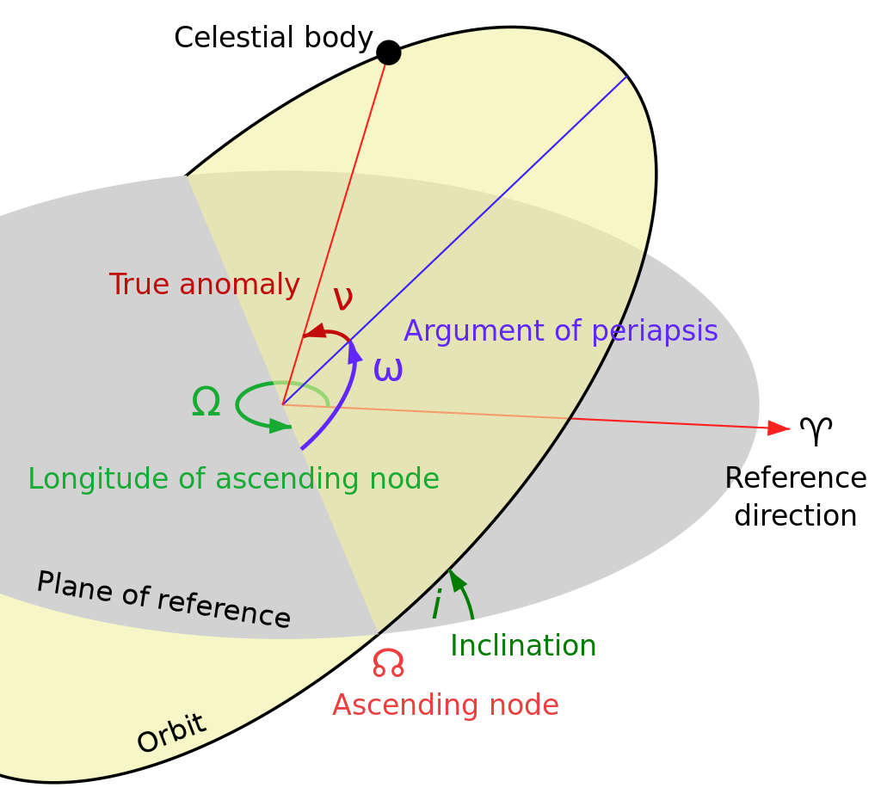

Figure 3. Kepler element of an orbit (‘Orbital elements’, 2023).

**Semi-major Axis (Unit: km):**

This is the longest radius of an ellipse, which describes the size of the orbit.

**Eccentricity (0-1):**

This measures the shape of the orbit, specifically how much it deviates from a perfect circle. A circular orbit has an eccentricity of 0, and an elliptical orbit has an eccentricity between 0 and 1.

**Inclination (Unit: radians, Range: 0- $π$):**

The inclination of an orbit represents the angle between its plane and a reference plane. For objects orbiting Earth, this reference plane is typically the Earth's equatorial plane. Satellites with orbits closely aligned to the equator have an inclination near 0 degrees. Conversely, orbits with inclinations approaching 90° pass over both the North and South poles.

**Longitude of the ascending node (Unit: degrees, Range: 0-2 $π$)**

The ascending node is indeed the point where an orbit crosses a reference plane from south to north or in an upward direction. The longitude of the ascending node (often symbolized by Ω) is the angle measured from a reference direction (typically the direction of the vernal equinox for objects orbiting the Sun, such as planets) to the ascending node.

**Argument of periapsis (Unit: degrees, Range: 0-360)**

The Argument of Periapsis (ω), depicted as a purple angle in Figure 3, determines the ellipse's orientation within the orbital plane. It's the angular measure from the ascending node to the periapsis, the point of closest approach to the primary object.

**True Anomaly (Unit: degrees, Range: 0-360)**

The true anomaly is the angle from the periapsis to the object's current position.

### Orbit type

With the rapid development of space technology, the classification of space objects has become particularly important. Among them, orbital altitude is the most basic and critical classification criterion, which is essential for understanding and predicting the performance and functions of satellites. For a deeper understanding of this categorization, several main orbital height categories and their associated applications are described as follows:

**Low Earth Orbit (LEO)**

A significant proportion of satellites, accounting for fifty-five percent of all operational ones, are located within what's termed as the low Earth orbit (LEO). Positioned at altitudes ranging from 160 to 2,000 kilometers, these satellites have the advantage of being relatively close to the Earth. As a result, they complete an orbit around the earth in a time span of roughly 90 minutes to 2 hours. This combination of proximity and rapid orbital periods positions LEO satellites as prime choice for tasks requiring frequent revisits or high-resolution data, such as science, imaging, and low-bandwidth telecommunications (Roberts, 2017; Via Satellite, 2021).

**Middle Earth Orbit (MEO)**

Satellites in medium Earth orbit (MEO) operate within an altitude range of 2,000 km to 35,586 km, positioned strategically between the widely recognized low Earth orbit (LEO) and the geosynchronous equatorial orbit (GEO), providing a unique operational advantage (The United States Government, 2019). MEO satellites provide a broader view of Earth than LEO satellites and faster transmission times than those in GEO due to their closer proximity. This makes MEO particularly advantageous for navigation systems, where broad coverage and quick signal transmission are pivotal.

However, the fewer number of satellites in MEO can be attributed to the challenges presented by the Van Allen belts—regions of high radiation that can adversely affect satellite operations. Located between 500 km to 5,500 km and 12,000 km to 22,000 km, these belts mean that satellites in MEO require protective shielding to ensure their longevity and functionality (Roberts, 2017; Via Satellite, 2021).

**Geosynchronous Equatorial Orbit (GEO)**

Geosynchronous Earth orbit (GEO) satellites occupy a unique altitude band ranging from 35,586 to 35,986 kilometres. The orbital period of these satellites coincides with Earth’s Day to the nearest 23 hours, 56 minutes and 4 seconds. This synchronization allows them to hover over the same point on the Earth's surface, making them ideal for continuous communications and continuous weather monitoring missions. Communications satellites at this altitude provide stable connectivity, while meteorological satellites provide real-time regional weather forecasts. Both GEO and LEO are favoured for the deployment of satellites, with GEO accounting for about 35 per cent of all operational satellites (Roberts, 2017; The European Space Agency, 2020).

**Highly Elliptical Orbit (HEO)**

A Highly Elliptical Orbit (HEO) is characterized by its significant eccentricity, which differentiates it from more traditional circular orbits. For an HEO, the perigee, or the point closest to Earth, can be just hundreds of miles above the surface, while the apogee, or the farthest point, can extend tens of thousands of miles into space.(Campbell, 2017)**.**

**Graveyard Orbit**

Graveyard orbit is a designated orbit to which satellites are moved at the end of their operational life to reduce the risk of collision with operational satellites and minimize space debris in commonly used orbital regions, such as LEO and GEO(Scott, 2019; The United States Government, 2019).

### Coordinate Reference System

**ECEF (Earth-Centered, Earth-Fixed):**

The ECEF coordinate system is a three-dimensional Cartesian reference frame with its origin situated at the Earth's center of mass. This reference frame rotates with the surface of the Earth, ensuring that any point on the Earth's surface has a fixed coordinate in this system(Rizzi and Ruggiero, 2003). The x-axis extends through the intersection of the Greenwich prime meridian (0° longitude) and the equator (0° latitude). The z-axis aligns with the Earth's rotational axis, passing through the true north and south poles. The y-axis is orthogonal to both, extending through the equator at 90° East longitude, near the Maldives in the Indian Ocean(Holmes, 2023).

**ECI (Earth-Centered Inertial):**

The ECI coordinate system also has its origin at the Earth's center but is designed to be nearly inertial, with its axes fixed relative to distant stars(Rizzi and Ruggiero, 2003). This means it doesn't rotate with the Earth like the ECEF does. While the term "inertial" suggests an ideally fixed frame where Newton's laws of motion apply without corrections, in reality, the ECI frame isn't perfectly inertial. Gravitational effects from celestial bodies, such as the Moon and Sun, cause minor accelerations in this frame. Despite this, for many Earth-centered applications, the ECI provides a close approximation to an inertial frame, though some precision tasks may require accounting for its slight non-inertial nature(Holmes, 2023).

## Visualization

Information visualization is a method of transforming abstract data and information into an intuitive, graphical form that makes it easier to understand, parse and remember that data. At the heart of this technique is the transformation of numbers, text, and other raw data into charts, graphs, and other visual forms that provide viewers with deeper insights and a better interactive experience with the data (Chen, 2010). Cartography belongs to the field of information visualization, which is primarily concerned with the cartographic representation and cartographic interaction.

### Cartography Representation

Central to the field of representation in cartography are key principles that ensure effective and coherent map design. According to Buckley(2012), there are five basic core principles of successful cartographic representation: legibility, visual contrast, site organization, hierarchical organization and balance. Among these, legibility and visual contrast ensure that map elements are clear and distinct; site organization, hierarchy and balance help to determine the importance of content and identify patterns. These principles are fundamental and complementary. The following section provides an in-depth discussion of these five design principles and their key role in communicating geographic information.

**Visual Contrast:**  
visual contrast is used to delineates map elements from their background. High contrast ensures clarity and prominence of specific features, while low contrast merges feature for a subdued impression.

**Legibility:**

Legibility refers to the clarity and comprehensibility of map elements. Proper symbol selection, familiar shapes, and appropriate sizes can enhance legibility. While geometric symbols perform well at smaller sizes, complex symbols require more space to visualize.

**Figure-ground organization:**

Figure-ground organization differentiates the main subject (figure) from the background. This design principle aids readers in concentrating on specific map areas. Techniques like adding map details or employing whitewash, drop shadows, or feathering enhance this separation.

**Hierarchical organization:**

Hierarchical organization refers to the visual structuring of information, allowing for the differentiation of features based on their significance. As described in "Elements of Cartography, Sixth Edition," a primary objective in mapmaking is to "separate meaningful characteristics and to portray likenesses, differences, and interrelationships"(Robinson *et al.*, 1995). This layering technique helps map readers to concentrate on key details and discern patterns. For instance, Reference maps, displaying various physical and cultural features, maintain a more balanced visual representation of elements, with no singular feature outweighing another. In contrast, thematic maps prioritize the primary theme over the foundational geographic details, emphasizing the distribution of specific attributes.

**Balance:**

Balance in map design refers to the harmonious arrangement of map elements, which ensuring stability and equilibrium in the composition. Elements such as the relative location, shape, size, and thematic content of element on the page play pivotal roles in achieving this balance. A well-balanced composition not only appears aesthetically pleasing but also can guide the viewer's emotions and perceptions.

However, in the era of digital transformation and the increasing emphasis on user-centered design, the Ordnance Survey has expanded upon this foundation by introducing additional principles that are attuned to the contemporary challenges and possibilities of map design(Ordnance Survey, 2022).

**Understanding user needs:**

Understanding user needs is critical for a map's efficacy. The clarity of a map's message depends on its projected use. Two guiding queries during the design phase are:

1. Which information do users seek?
2. How will they engage with the map?

Maintaining focus on these aspects prevents the inclusion of irrelevant elements that might detract or confuse.

**Consideration of display format**

To ensure optimal clarity in cartography, the intended display medium is paramount. Decisions on medium dictate design elements like colour mode (RGB for digital; CMYK for print), text sizing for legibility, and potential interactivity. Thus, a map's design intricacies are intrinsically linked to its display context.

**Simplicity**

Including irrelevant details in cartography can hinder the efficiency of translating spatial data into knowledge. It is critical to weigh the utility of the information against the risk of map clutter and the ensuing confusion.

**Consistency**

Consistency in cartography promotes a sense of familiarity and coherence, thereby facilitating effective communication. Organizing features in a consistent manner enhances a sense of grouping and solidifies the identity of the map within the product family. Repeated use of the same symbols improves user recognition, while inconsistent symbols can obscure the map's message and cause confusion.

**Accessibility**

Ensuring the accessibility of maps is critical to their successful utilization. This includes considerations such as user-friendly distribution formats, addressing disability issues, affordability and intuitive design. With the popularity of digital maps, it is critical to prioritize accessible file formats and compatible software. In addition, designs should take into account the abilities of users, including considerations for persons with color vision impairments.

### Cartography Interaction

Interactive cartography has been defined as a form of dialog between a person and a map, via a computing device (Roth, 2012).Its core objective is to ensure that users can easily access and manipulate task information at the right time (Rosson and Carroll, 2002). For successful interactive cartography, understanding the process of interactive realization is essential. In this context, Norman's stages of (inter)action model offer a systematic explanation of this process, encompassing seven distinct steps:

* Forming an open-ended goal
* Specifying a concrete intent toward that goal
* Designating an action or system function in line with the intent
* Executing that action via an input device
* Observing the system's current state
* Analyzing and deciphering the implications of system changes
* Evaluating the outcome to ascertain if the primary goal was met (Roth, 2013b, as depicted in Figure 4)

Central to interactive cartography are cartographic interaction primitives - the fundamental units of interactivity. These primitives often work in concert with other primitives to enhance the user's experience of interacting with an interactive map (Roth, 2012). Extant taxonomies categorize interaction primitives in three different ways:

* Objective-based, which aligns interactions with the "Forming the Intention" stage, emphasizing the objectives users might have within a cartographic interface. Key primitives in this category are “identification” and “comparison”.
* Operator-based, associating interactions with the “Specifying an action” phase, pinpointing the specific tools or actions that might be utilized to meet objectives. Central primitives in this category include “brushing”, “focusing”, “linking”, and “zooming”.
* Operand-based, which classifies interaction primitives based on the characteristics of the recipient of the interaction operators, with prime interactions “temporal”, “data”, and “object”(Roth, 2012, 2013a, 2013b).

While all three approaches are considered to be helpful in designing interactive maps, the focus of this chapter stays on the operator-based approach because of its relevance to the components of map interface design. For operator based approaches, interaction primitives can be categorized into "working operators" that contribute to the achievement of goals and "enabling operators" that contribute to the preparation and completion of the phases of working operators. Table 1 presents a detailed list with descriptions of the complete set of operator-based interaction primitives.

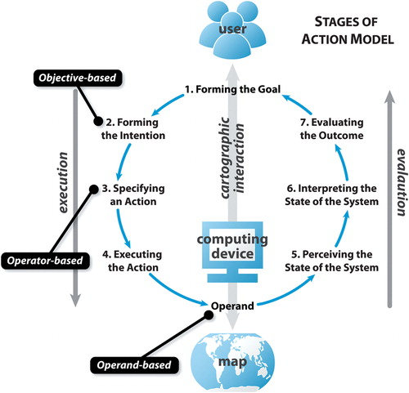

Figure 4． Stages of Interaction based on Norman's stages of (inter)action model(Acharya, 2021).

Table 1. List of interaction operator primitive (Roth, 2013a)

|  |  |  |  |
| --- | --- | --- | --- |
|  | | Interaction operator primitives | Description |
| Work Operator Primitives | Reexpress | | Changes how data is visually represented on a map, such as altering the map type or switching between linear and logarithmic displays. |
| Arrange | | Manipulates the layout of views in a coordinated visualization |
| Sequence | | Generates a series of related maps that display subsets of geographic information, such as animations that show changes over time. |
| Resymbolize | | Adjusts design parameters of a map without changing the map type itself, like altering the color scheme or dot value. |
| Overlay | | Modifies the features shown on the map, either by adding/removing layers or changing mapped attributes. |
| Reproject | | Alters the map projection, translating the Earth's curved coordinates onto a flat plane. |
| Pan | | Changes the geographic center of the map. Some view this operator as also encompassing changes to viewing angles. |
| Zoom | | Adjusts the map's scale and/or resolution, magnifying or reducing its detail. |
| Filter | | Identifies map features based on user-defined conditions. It can lead to emphasizing or de-emphasizing certain map features. |
| Search | | Helps locate specific map features based on direct identifiers like name or address. Different from "filter", as it seeks a direct match. |
| Retrieve | | Requests detailed information about specific map features through direct manipulation (e.g., click on features) |
| Calculate | | Generates new information or statistics about map features, emphasizing the need for a closer relationship between visualization and computation in cartography. |
| Enabling Operator | Import | | Allows users to load datasets or pre-made maps into the visualization, with potential for dynamic real-time data feeds from online sources. |
| Export | | Extracts created maps or the underlying geographic data for use outside the current visualization environment. This could be for tasks like printing the map or producing a report. |
| Save | | Preserves the map, its underlying data, or the system status for future use within the same visualization system. Supports undo and redo functionalities and is distinguished from export based on the future use setting (internal vs. external). |
| Edit | | Alters the actual geographic data underpinning the map, impacting all future visual representations of that data. This operator encompasses actions like adding, deleting, and manipulating objects. |
| Annotate | | Allows users to enhance visualizations with added graphics and textual notes. This aids in externalizing insights directly on the map and supports the analytical and cognitive processes during interaction. |

Among these interaction primitives, pan, zoom, retrieve, filter and search are fundamental primitives to the interface design. Other primitives can be added depending on the purpose of the map design and the goals of the user. However, it is important to keep the design simple to ensure that the interface is user-friendly

### Existing Space Object Visualizer

This section reviews 4 existing space object visualizers that can be used by the public. The main research is on interaction primitives in those spatial object visualizers.

Table 2. Review of operator primitives in the existing space object visualizer.

|  |  |
| --- | --- |
| Visualizer | Interaction primitives (operator) |
| [SpaceAware.io](https://spaceaware.io/)  (SpaceAware.io, 2023) | **Pan, Zoom, Retrieve** (Name, NORAD ID & COSPAR ID & owner & apogee & perigee & object type), **Filter** (object type & perigee & period & inclination & owner), **Overlay (**Name & NORAD ID & add orbit**)**, **Reexpress** (ECI & ECEF), **Reproject**, **Search** (Name, NORAD ID & COSPAR ID & owner & apogee & perigee & object type), **Sequence, Calculate** (Accounting of conjunction and space object). |
| [Leolab’s Low Earth Orbit Visualization](https://platform.leolabs.space/visualization)  (Leolab, 2023) | **Pan, Zoom, Retrieve** (Name & catalog number & NORAD ID & object type & inclination & perigee & apogee & period), **Filter** (object type & perigee & period & inclination & owner), **Overlay** (catalogue number & COSPAR Name & highlighting object), **Reexpress** (Ground view & orbit view), **Search** (Name), **Sequence.** |
| [satvis.space](https://satvis.space/)  (Satvis.space, 2023) | **Pan,** **Zoom,** **Retrieve** (Name, position, ground station, relative TLE)**,** **Filter** (Operational status & functionality & application & object type & owner)**,** **Overlay** (COSPAR Name & operational status)**, Reexpress** (ECI & ECEF)**, Reproject, Search** (COSPAR ID& Name), **Sequence.** |
| [esri satellite map](https://geoxc-apps.bd.esri.com/space/satellite-explorer/)  (esri, 2023) | **Pan, Zoom, Retrieve** (Name, application, launch date, operator, NORAD ID)**, Filter** (Application, Orbit type, owner, debris for special event), **Overlay** (highlighting orbit)**, Calculate** (Accounting based on application, owner, orbit type, debris for special event). |

## User-Centered Design

**Definition and importance**

User-Centered Design (UCD) is an iterative design methodology that places the user at the center of the design and development process, ensuring that products and services are tailored to meet the specific needs, preferences, and contexts of end users(Zerlinda, 2019). The rise of UCD in the field of modern design and development is attributed to four key insights: 1) The distinction of view point between an expert and a typical user; 2) The ambiguous initial need of users; 3) The changing nature of user’s need; and 4) The variegation of user type (Robinson, MacEachren and Roth, 2011). Through effective user centered design, the usability of interfaces can be improved, leads to higher user satisfaction and gains a competitive advantage in the marketplace. Moreover, by meeting user needs early, companies can significantly reduce the cost of redesigns and minimize late-stage support challenges(NI Business Info, 2023).

**The stages of UCD**

The implementation of UCD involves several key steps, Nielsen's seminal work in usability engineering provides valuable guidance by outlining ten key “elements” of the user-centered design process(Nielsen, 1992, 1994), which are 1) Know the User; 2) Competitive Analysis; 3) Setting Goals 4) Participatory Design; 5) Coordinated Design 6) Guidelines and Heuristic Analysis; 7) Prototyping; 8) Empirical Testing; 9) Iterative Design; and 10) Collect Feedback from Field Use. Based on these 10 “elements”, multiple UCD frameworks are defined(Gabbard, Hix and Swan, 1999; Hix *et al.*, 1999; Slocum *et al.*, 2003; Robinson *et al.*, 2005; Tsou and Curran, 2008). Among these UCD frameworks, the most common work is the one developed by Robinson *et al.*(2005) with six iterative stages: 1) an initial work domain analysis, delving into user needs and primary research; 2) a subsequent conceptual development, outlining the application's desired attributes derive from the previous user needs research; 3) prototyping to optimize usability relative to the identified utility attributes; 4) conducting interaction and usability studies to gather user feedback on the prototype; 5) the implementation phase, making request modifications based on feedback; and 6) a final debugging stage to ensure application stability (Figure 5).

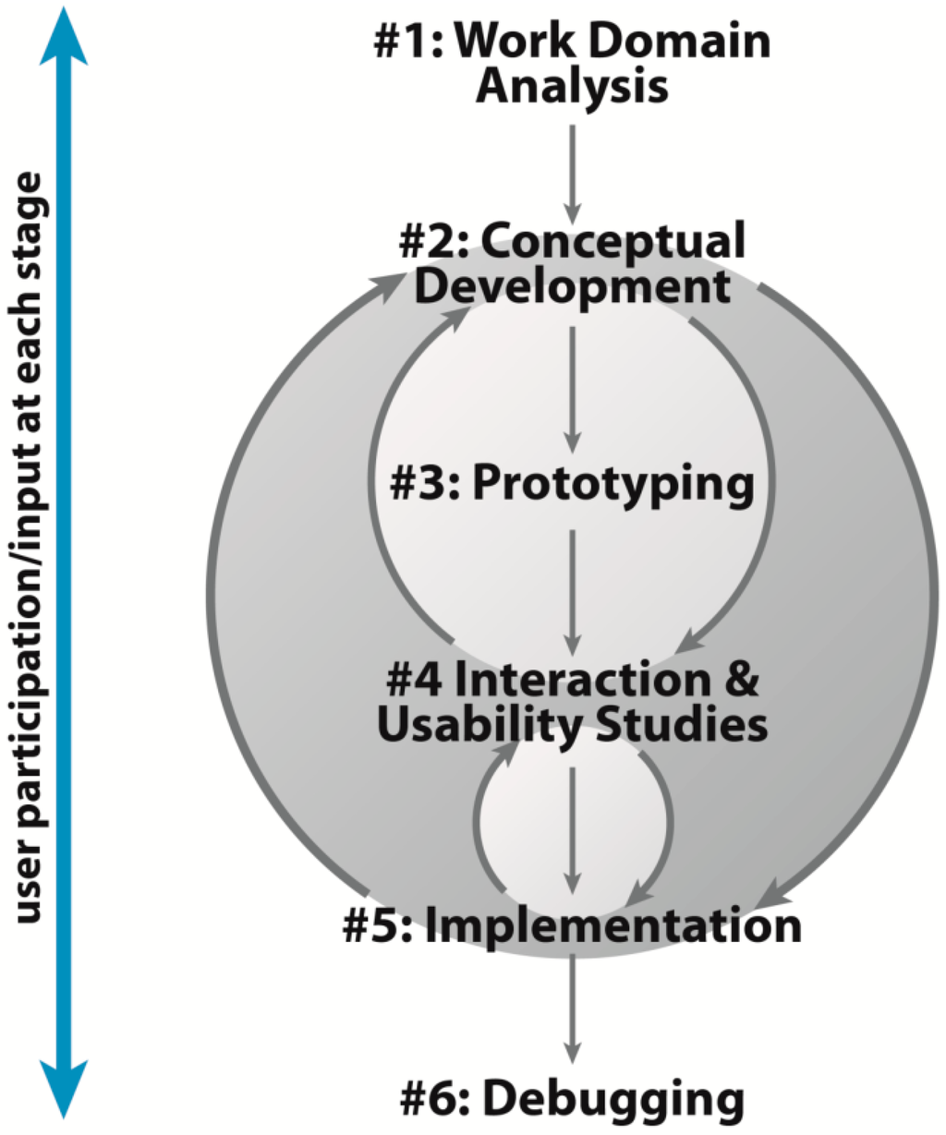

Figure 5. A highly iterative user-centered design process adopted from Roth, Ross and MacEachren (2015).

**Persona**

As mentioned in the stages of user-centered design, the first step is to conduct a user needs assessment. Understanding the target user is the first step in this phase. This introduces a new concept of Persona, fictional characters based on actual user prototypes, whose goals and characteristics are the "average" representation of a large group of actual users (Faller, 2019, 2019; Zerlinda, 2019). To build up one or more effective personas, the first step is to collect the information from the users, then summarize the characteristics of users in detail, such as age, literacy, and goals etc. If there is multiple personas, priority of personas is needed to clarify the theme of the design. Finally, binding the personas with an imagined situation that describes how a Persona would interact with a product in a particular context to achieve its end goal(s) to make the persona valuable(Faller, 2019).

**Evaluation of the design**

Evaluating interface design through user research is critical in the user-centred design process as it is the key to iterative improvement (Figure 5. Stage 4). Usability and utility are two crucial measures introduced for this evaluation(Robinson, MacEachren and Roth, 2011). Usability, in particular, evaluates the quality attributes of an interface, focusing on its ease of use. Nielsen (2012) delineates usability into five core components:

* **Learnability:** Upon first interaction with the design, how straightforward is it for users to complete essential tasks?
* **Efficiency:** After users become acquainted with the design, how quickly do they accomplish the task?
* **Memorability**: If users stop using the design for a period of time, how quickly can they regain expertise after reusing it?
* **Errors:** How frequently and seriously do users make errors, and how easy is it for them to recover from those errors?
* **Satisfaction:** The degree of pleasure or contentment users derive from interacting with the interface.

As for utility, the design is examined to see if it meets the needs and tasks of the user to ensure that the design is not only functional but also accomplishes the intended task(Nielsen, 2012; Roth, Ross and MacEachren, 2015).

Instead of conducting a singular, large-scale, and potentially costly study, the iterative design approach recommends engaging only five participants. This smaller group is sufficient to uncover the majority of significant usability issues (85%), making it a cost-effective and efficient strategy(Nielsen, 2000; Vredenburg *et al.*, 2002).

## Web technology

### HTML, CSS and JavaScript

In the field of web building, three main languages are often used at the forefront: HyperText Markup Language (HTML), Cascading Style Sheets (CSS), and JavaScript (JS). HTML lays the foundational structure of a webpage, structuring the content by encapsulating different elements such as text, images, and links. On the other hand, CSS is responsible for the visual appeal, dictating the design, colors, fonts, and layout. JavaScript then brings interactivity to the table, introducing features like animations, real-time data updates, and interactive forms. Together, these technologies empower developers to create dynamic, visually appealing, and user-friendly web pages and applications(Cox, 2021).

### Cesium JS

CesiumJS is an open-source JavaScript library, birthed from a project at Analytical Graphics, Inc. in 2011, that stands at the forefront of 3D globe and map visualization. Renowned as the world's most accurate, performant, and time-dynamic virtual globe, it provides a versatile platform for developers across various sectors, from aerospace to smart cities. Developers use CesiumJS to craft interactive web applications that disseminate dynamic geospatial data. Built on open standards, it champions interoperability and scalability. With its Apache 2.0 licensing, it's available for both commercial and non-commercial endeavors, and its robustness is evident with over a million downloads(Cesium, 2023; SourceForge, 2023).

### Netlify

Netlify is an advanced web hosting and deployment platform designed primarily for developers focusing on static or Jamstack websites. It boasts outstanding features such as automated code deployment, serverless feature execution, free HTTPS certificates, instantaneous cache invalidation, and extensive edge network distribution. Notably, Netlify has launched a " Starter " plan, which is tailored for individual users for personal projects, prototypes or those who wish to dive deeper. The program starts at $0 and offers deployment to a global edge network, live site preview paired with a collaborative user interface, 100GB of bandwidth and 300 minutes of build time, instant rollback to any previous version, and the ability to deploy static assets and dynamic serverless features(Netlify, 2023).

# Methodology

## Design technology

The visualizer was developed using Cesium JS for 3D/4D visualization, using its powerful features to display engaging 3D effects. Combining HTML and CSS, the visualizer achieves an attractive interface and presentation of information, while the JS programming allows the user to interact dynamically. Finally, for accessibility, the visualizer was deployed as a static website via Netlify, allowing test users to use the visualizer via a web address, rather than downloading all the relevant files and opening them via a local server.

## Data

The data used in this project was supported by the UCL Future Space Population Study. A total of four files are included, corresponding to space population data for 2019, 2023, 2028, and 2043. In this project, space population is defined as trackable (man-made) objects (with characteristic length > 10 cm) on orbit around the Earth, at altitudes > 100 km but < 50,000 km. In FSP data, debris is excluded from the result for visualization. It is worth noting that the FSP data does not contain debris, instead it is discussed separately in the FSP study. The FSP data consists of a total of 29 fields, as shown in the table below.

Table 3. List of fields in the FSP catalogue.

|  |  |  |  |
| --- | --- | --- | --- |
| Field name of FSP catalogue | | | |
| 1 | COSPAR_ID | 16 | apogee_hgt (km) |
| 2 | RSO_name | 17 | perigee_hgt (km) |
| 3 | RSO_type | 18 | radar_cross_section (m^2) |
| 4 | payload_operational_status | 19 | characteristic_area (m^2) |
| 5 | orbit_type | 20 | charactersitic_length (m) |
| 6 | application | 21 | propulsion_type |
| 7 | owner | 22 | orbital_status_code |
| 8 | launch_site_code | 23 | epoch_of_orbit |
| 9 | launch_date | 24 | semi_major_axis (km) |
| 10 | decay_date | 25 | eccentricity |
| 11 | orbital_period (minutes) | 26 | inclination (radian) |
| 12 | mass (kg) | 27 | argument_of_perigee (degree) |
| 13 | maneuverable (True/False) | 28 | RAAN (degree) |
| 14 | spin_stabilised (True/False) | 29 | true_anomaly (degree) |
| 15 | inclination_deg (radian) |  |  |

In this project, User Centered Design (UCD) was applied to the design process of a satellite visualization application. The design process followed the highly iterative user-centered design process adopted by Roth, Ross and MacEachren (2015).

## Work domain analysis:

As described in Chapter 2.4, the first step in UCD is to analyses and identify the target users and then investigate the needs of these users. Due to time constraints, and to ensure a high response rate to the survey, this report has been initially filtered for background rather than having no restrictions. The filtering was set to the postgraduate student population of the UCL CEGE department.

Initial communication through social networking software was used to identify students who showed some interest in the future space population. Subsequently, non-private information and related needs were collected using social media, and a corresponding 'Persona' was created. The text box below shows the " persona " that represents an average user for 7 participants.

**Persona**

***Demographics***

**Age:** 22-24, in adult.

**Software experience:** Medium-High (Familiarity with web application navigation)

**Knowledge about space objects:** Low-Medium (Some knowledge of space objects, but not very specialized.)

**Occupation:** Postgraduate student in UCL CEGE department.

***User story***  
The user has already shown some interest in the future space population and is willing to explore more about it.

***Objectives***

1. Want to know the future distribution of space population in different orbits.
2. Want to know which countries or organizations have the largest space populations.
3. Want to compare how the future space population has changed over the years.
4. Want to know the distribution of the future space population at different altitudes.

## Conceptual development

After ‘Persona’ was built, is the identification of desired utility attributes relative to the requirement of the user. These attributes are the baseline for the interface design. The table below list the utility bassline for the interface design.

Table 4． List of uitlity basline for the design of the visualizer

|  |  |
| --- | --- |
| Objective | Utility baseline |
| 1 | Displaying the FSP in different orbit |
| 2 | Ranking the owner of the FSP |
| 3 | Compare the PSP in different years |
| 4 | Displaying the FSP at different attribute |

## Prototyping

Based on the interface baseline, this step focuses on improving the usability of the interface. By reviewing the literature on cartographic representation and cartographic interaction, it can be determined what potential interaction primitives exist for designing interfaces and how to efficiently present the relevant information, including layout, map elements, color scheme, etc. In addition to this, a review of the interaction primitives within the four existing spatial object visualizers was conducted to aid this research in designing interactions. After reviewing all the related information, alpha version of the visualizer released in this step.

The expected design outcomes and their relative reasoning are set out below:

### Separate page design

This design comes from the requirement for simplicity in cartographic representation(Ordnance Survey, 2022). As the baseline visualizer used for this design enhancement, Luyang's visualizer places all content on the same page, which is redundant and distracting for users who don't need the relevant content (Figure 7) (Luyang, 2021). Separate HTML pages based on different information and functions can effectively ensure simplicity of presentation, e.g., the radar window interface is moved to a separate radar page and the statistical chart to a separate dashboard page.

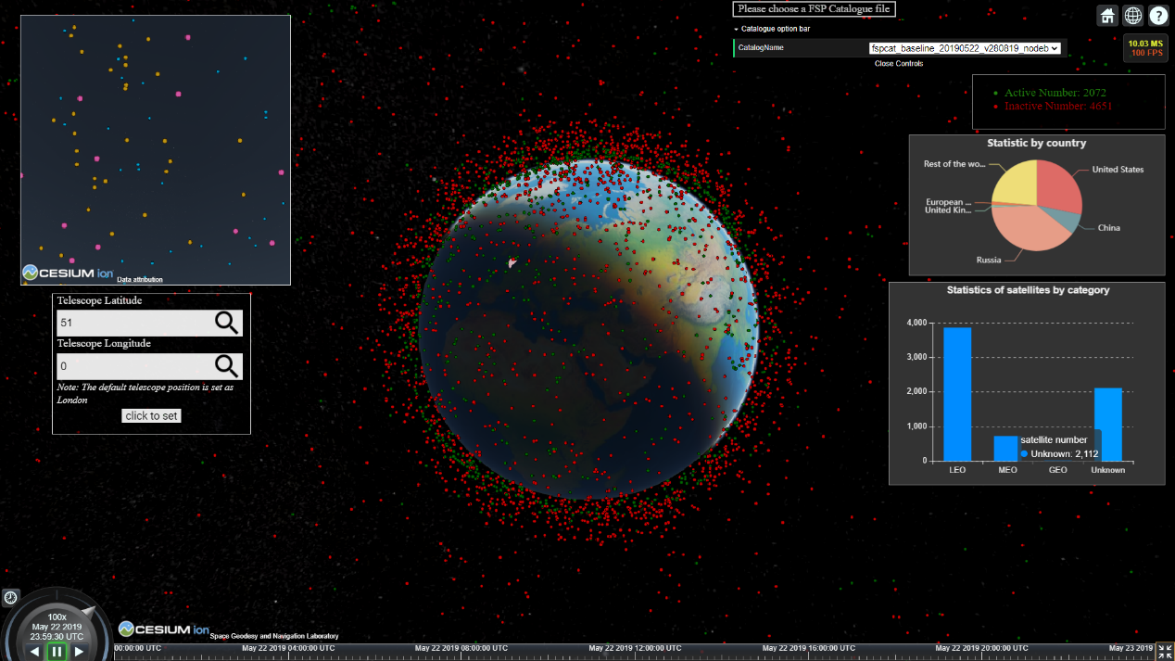

Figure 6. Luyang’s enhanced Future Space Population visualizer(Luyang, 2021).

### Search Bar for COSPAR ID

Search is one of the key interaction primitives for web map design that allows users to locate specific map features based on direct identifiers such as names or addresses. It is very common in existing spatial object visualization tools, and the main search objects are COSPAR ID and COSPAR Name. The search object for this project is set to COSPAR ID because COSPAR ID is unique compared to COSPAR Name.

### Information box for click event

Retrieve is one of the key interaction primitives for the map design that allow users to get detailed information about specific map features through direct manipulation (e.g., click on features). It is very common in existing space object visualization tools and displays common information about the space object such as NORAD ID, COSPAR name, and owner. Optional information includes inclination, apogee, perigee, etc. Based on the available fields in the FSP data and consideration that Persona users are not specialized in space objects, the information displayed in the information box includes COSPAR ID, COSPARD name, object type, orbit type, operational status and owner.

### Highlighting object and adding orbits through click event

Overlay is one of the key interaction primitives for the map design that allow users to modifies the features shown on the map, either by adding/removing layers or changing mapped attributes. It is very common in existing spatial object visualization tools and usually consists of highlighting selected features (circles or changing color), along with associated labeling information, such as the COSPAR name. Options can be designed for adding relative orbits. In this project, the object is highlighted by increasing the size and changing color, and a colored orbit is added to add interactivity to the click event, depending on the operational status. It is worth noting that in order to show orbits in the familiar ellipsoid shape, this design has changed the original ECEF coordinate reference system, where the coordinate reference system rotates with the rotation of the Earth, to ECI coordinate reference system, where the coordinate reference system rotates with the rotation of the Earth(Holmes, 2023).

### Filter button for specific orbit type and top 10 space objects owner

Filter is one of the key interaction primitives of map design, allowing users to identify map features based on user-defined criteria. It can emphasize or de-emphasize certain map features. It is very common in existing spatial object visualization tools and is usually used to filter objects based on object type or owner. Given the persona's objective to understand the spatial population distribution of different orbits in the future, as well as to categorize owners by the number of space objects they owned. To ensure the utility of the visualization tool and to improve interactivity, filter buttons for specific orbit types and top 10 owners were added to the visualizer.

### Selection bar for filtering object based on its owner

This design enhances the functionality described in Chapter 3.3.5. While the initial filtering was only for the top 10 ranked space object owners based on Persona's needs, people may be interested in other owners outside of the rankings. To address this, the design now includes a filtering option for non-ranked owners, whose names are listed in alphabetical order for easier navigation.

### Percentage bar for LEO, MEO, GEO and Top 10 owner

Calculate is one of the key interactive primitives of map design, allowing users to generate new information or statistics about map features, emphasizing the need for a closer relationship between visualization and calculation in cartography. By changing the loaded file in the FSP visualizer, the number and percentage of space objects for LEO, MEO, GEO and Top 10 owner are displayed as percentage bar charts.

### Click events for radar window

Combining the design of chapter 3.3.3 and chapter 3.3.4, a click event is added to the radar window. When the user clicks on a point in the radar window, the radar window highlights the point, and the main screen also highlights the selected point, adds the corresponding orbit and displays the information box. This design was added mainly in consideration of the principle of consistency in cartographic representation. As a sub-window, the radar window should be consistent with the main window when dealing with click events, in order to avoid users who are already familiar with the click events in the main view. Meanwhile, this design can also strengthen the connection between the radar window and the main window, making the design more interactive.

### Legend for radar window

The legend is one of the most important elements in cartography, representing all the information about the symbol on the map and what it represents (SpatialPost, 2021). As shown in Figure 6, Luyang's visualizer does not add a legend to the points in the radar window, which makes his representation of points in different sizes and colors based on the radar cross-section defective in presenting the information. In addition, to improve the visualization, the number of symbols and colors in the legend should be simple and clear (SpatialPost, 2021). Luyang choose to change both the size and color of the points to indicate differences in radar cross sections is redundant. Therefore, the representation of the points in the radar window is modified to show the differences in the radar cross section based on the size of the points, while the color of the points is kept the same as the color set in the main window based on the operational status. This ensures that the differences in the radar cross-section are emphasized by the size of the dots, and that one more piece of information, the operational status, is displayed.

### Custom Orbit Page

To support education in the field of orbital science, assist in orbital design of space missions and collision predictions, the visualizer was designed with a "Custom Orbit" page(Truchly and Cervienka, 2016). Considering the distinctive nature of the FSP results, the page not only allows the user to choose whether to load the FSP simulation results, but also provides the ability to draw custom orbits by inputting Kepler elements, including Semi-major axis, eccentricity, Inclination, Longitude of ascending node, argument of perigee(periapsis), and True anomaly. This design provides users with a tool to simulate and design orbital conditions for future space scenarios, resulting in a more forward-looking approach to orbital design and collision prediction for space missions.

### Background information for orbit types and Kepler elements

Considering that Persona is not an expert in the field of space objects, there may be problems in understanding the results of the FSP visualization that are difficult to comprehend. This design has been implemented in the Orbits page and the Custom Orbits page adds background information to ensure that users can more deeply and easily understand the design of the Visualizer and the meaning behind it (Chiaro, 2021). This includes detailed information about the different types of orbits and their definitions, as well as the specific meanings of the Keplerian elements. By providing such supporting information, users are better able to interact with the visualizer and benefit from its design.

### Dashboard Page with custom chart style

In order to provide users with a quick overview of the FSP results, a dashboard is introduced in this design that summarizes the statistical information for each of the key fields in the FSP results that relative to the Persona’s objective (Adjust, 2023). For each field, two display methods that are most suitable for presenting the relevant data are provided and placed above the chart in the form of a selection bar.

### User guide and reference page

These two pages were designed to improve the user experience, i.e., a user guide to help users understand how to use the visualizer more easily, and a reference page to allow users to explore further background information behind the visualizer.

### Modification of the identification regarding track type and owner

As the baseline visualizer used in this design, Luyang calculates and displays the number and percentage of space objects owned by different owners, as well as the number of space objects in different orbits through statistical charts (Figure 6) (Luyang, 2021). However, there are some problems with the identification method he uses, making the information conveyed to the user misleading. Below is the code developed by Luyang used to identify orbit type and owner:

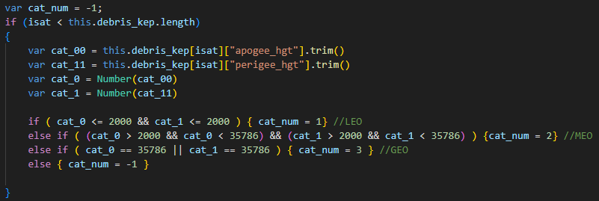

Code example 1 – Example code used to define the orbit type.

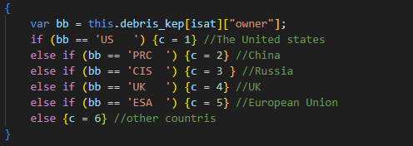

Code example 2 – Example code used to define the owner.

While based on the definition provide by The United States Government (2019), the altitude of LEO is below 2000km, GEO is between 35596-35986km, and MEO is between LEO and GEO. Luyang's definition of orbit height is only theoretical data, and there is some deviation in practice. So, this design has corrected this. Meanwhile, this design also adds the identification of HEO, which effectively reduces the number of unknowns in the orbit identification, taking the data of 2019 as an example, the number of unknowns decreases from 2112 to 265. The remaining unknowns are due to the inaccuracies and complexities of orbital prediction models (like SGP4) and the uncertain status of some objects(Vallado *et al.*, 2006; Graveyard orbit, 2023). These objects could be retired satellites or debris in a "Graveyard orbit", whose exact state and location may not be accurately tracked, resulting in their inability to be classified into LEO, MEO, GEO, or HEO categories.

Below is the new code for Orbit type identification:

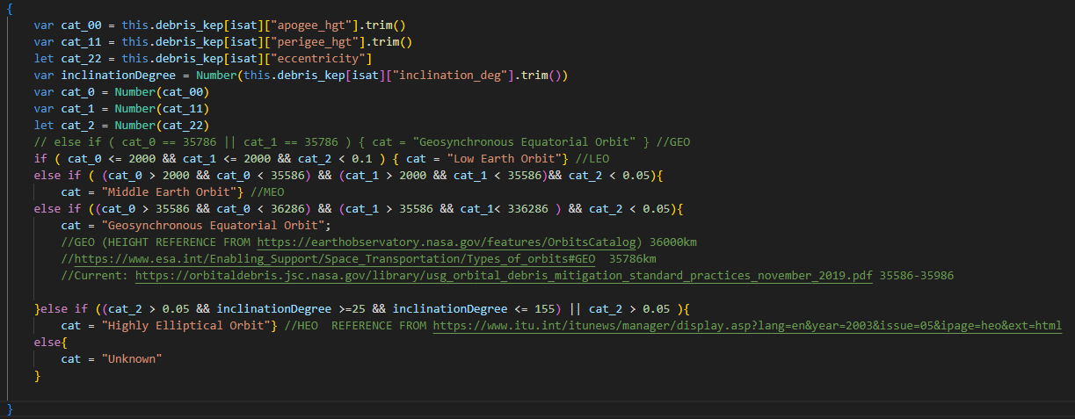

Code example 3 – Example code used to define the owner.

For the identification of owner, Luyang directly identifies CIA, Commonwealth of Independent States (former USSR) as Russia, and ESA (European Space Agency) as European Union. This is a wrong definition because the abbreviation for owner in the FSP data referenced from the Celestrak ownership document, whereas the CIA stands for all countries after the dissolution of the former Soviet Union. Also, the European Union is not only ESA, but also FR (France), GER (Germany) and so on. To make the correction, the full version of Celestrak's owner document is used to support the identification(CelesTrak, 2023).

### Adding default catalogue file for visualization

This design was introduced based on the recommendations of the Indigo user study (Indigo, 2021). The purpose of the design is to enable the visualization tool to display certain information on initial load, rather than starting with a completely blank state and having to wait for the file to finish loading before displaying the information.

## Interaction & Usability Studies

To evaluate the alpha version of the visualization tool, a usability test was used with additional open questions on utility and future development. The questionnaires were designed on Microsoft Forms and sent as a link to users participating in the user requirements survey. The form of the questionnaires are anonymous and does not require the user to provide sensitive information, which allows for a more realistic response and guarantees a response rate to a certain extent(Szyndlar, 2023).

There are two questionnaires covering both quantitative and qualitative questions. The first questionnaire focuses on Usability-related components and Utility (Table 5). The quantitative questions focus on nine questions related to Learnability, one question related to Efficiency, one question related to Errors, and ten questions related to Satisfaction. In addition, the questionnaire included one question related to Utility, as well as one qualitative question on suggestions for future Improvement. The second questionnaire focused on assessing memorability in usability (Table 6). For this purpose, the questionnaire was dispensed one day after the completion of the first questionnaire. This arrangement is based on the original of the forgetting curve, where newly learned content is forgotten more than 80% within 24 hours of learning it (Ebbinghaus, 2021).

Table 5. The questionnaire focuses on components related to usability (learnability, efficiency, errors, satisfaction) and utility.

|  |  |  |
| --- | --- | --- |
| Assessing Component | Type | Question |
| Learnability | Scale (1-5) | 1. (On Home Page) How easy is it for you to view the space population for 2023, 2028, and 2043? |
| Scale (1-5) | 1. (On Home Page) How easy is it for you to turn on the time change and change the time multiplier? |
| Scale (1-5) | 1. (On Home Page) How easy is it for you to search the COSPAR ID: 1975-016A? |
| Scale (1-5) | 1. How easy is it for you to switch to the Orbits page (or any other pages) and then back to the home page? |
| Scale (1-5) | 1. How easy is it for you to filter the specific type of orbits for visualization in Orbits page? |
| Scale (1-5) | 1. (Please exit current page and go to Owners Page) How easy is it for you to filter the objects belonging to the Top 1 Owner by using available tools on Owners page? |
| Scale (1-5) | 1. (Please exit current page and go to Radar Page) How easy is it for you to find the point in the radar window where the main window is located through the click event on Radar page? |
| Scale (1-5) | 1. (Please exit current page and go to Custom Orbit Page) How easy is it for you to create your own orbit on Custom Orbit page? |
| Scale (1-5) | 1. (Please exit current page and go to Dashboard Page) How easy is it for you to change the style (i.e., switch between the scatter plot and histogram) of visualization for the height distribution part on Dashboard page? |
| Efficiency | Scale (1-5) | 1. (Please exit the current page, back to the Home Page, and click the icon "i" to read the user guidelines) After reading the instruction, were you able to complete previous questions (Q1-9) easily and quickly? |
| Satisfaction | Scale (1-5) | 1. How pleasant is the general layout of the Home Page? |
| Scale (1-5) | 1. How pleasant is the design of individual pages based on information or functionality (except for the home page)? |
| Scale (1-5) | 1. How pleasant is the use of search bar? |
| Scale (1-5) | 1. How pleasant is the filter function (buttons and selection bar)? |
| Scale (1-5) | 1. (You may to switch to the Orbits and Custom Orbit Pages) How pleasant is the background information design? |
| Scale (1-5) | 1. How pleasant is the design of click events (highlighting selected objects, adding orbits and information box)? |
| Scale (1-5) | 1. (Please go to the dashboard page) How pleasant is the optional display style? |
| Scale (1-5) | 1. (Please go to the radar page) How pleasant is the addition of legend? |
| Scale (1-5) | 1. How pleasant is the adding of user guideline and reference page? |
| Scale (1-5) | 1. (Please go to the Custom Orbit page) How pleasant is the Custom Orbit design? |
| Error | Scale (1-5) | 1. Have you encountered any problem or error in the visualizer that are affecting its use? |
| Utility | Scale (1-5) | 1. Does this visualizer support you to understand the future space population variation in the next few years especially for your initial objective? |
| Future improvement | Text box | 1. Could you give some suggestions for the future development? (i.e., artistical design, layout, functions improvement etc.) |

Note: The scale used for assessing Learnability and Efficiency ranged from 1 (Very hard) to 5 (Very easy). The scale for assessing Satisfaction ranged from 1 (Very dissatisfied) to 5 (Very satisfied). The scale for assessing Error ranged from 1 (Full of errors, cannot use it) to 5 (No errors happened, everything is fine). The scale for Utility ranged from 1 (Strongly disagree) to 5 (Strongly agree).

Table 6. The questionnaire focuses on the component of usability (Memorability)

|  |  |  |
| --- | --- | --- |
| Assessing component | Type | Question |
| Memorability | Scale (1-5) | After one day, when you use it again, are you able to easily become proficient in it again? |

Note: The scale used for assessing the Memorability ranged from 1(VERY DIFFICULT: When I used the design again after a day, I was so confused and unsure that I almost forgot how to use it.o use it.) to 5 (VERY EASY: I re-skilled the design almost immediately and it feels like I just used it yesterday).

## Revised conceptual development and interface design (Implementation)

As can be seen in Figure 5, there is an iterative process between Step 2 (concept development) and Step 5 (implementation). Specifically, this step is to modify the user requirements and interface design based on the results of the interaction & usability study. The user requirements and interface design are modified through one or more interaction and usability studies, resulting in the final version of the interface. While for this project, the interaction & usability study only operate once due the time limitation.

## Debugging

This is the final stage of UCD design and aims to eliminate minor usability errors and improve stability, with improvements based on errors captured by open questions in interaction and usability studies.

# Result

This section will be presented and described in three stages: Alpha version, Interaction & Usability study results, and Beta version. These are the result correspond to the Chapter 3.5, Chapter 3.6 and Chapter 3.7.

## Alpha version

Figure 7 gives an overview of the results of the enhancement of the entire Alpha version of the visualizer. The blue boxes are the added design, the green boxes are the relocated design, and the yellow boxes are the modified design. There are three sections, Users, Interactions, and Interfaces, separated by black dashed lines. The blue lines between each section represent correlation. Taking the dashboard page as an example, the page is designed as a relocated design, as the statistical chart in the original visualizer is relocated to this page. Filter is added to the page as the core interaction primitive, the interaction is in the form of a selection bar, and the content of the interaction is the type of presentation of the statistical chart and with the user as the interaction target.

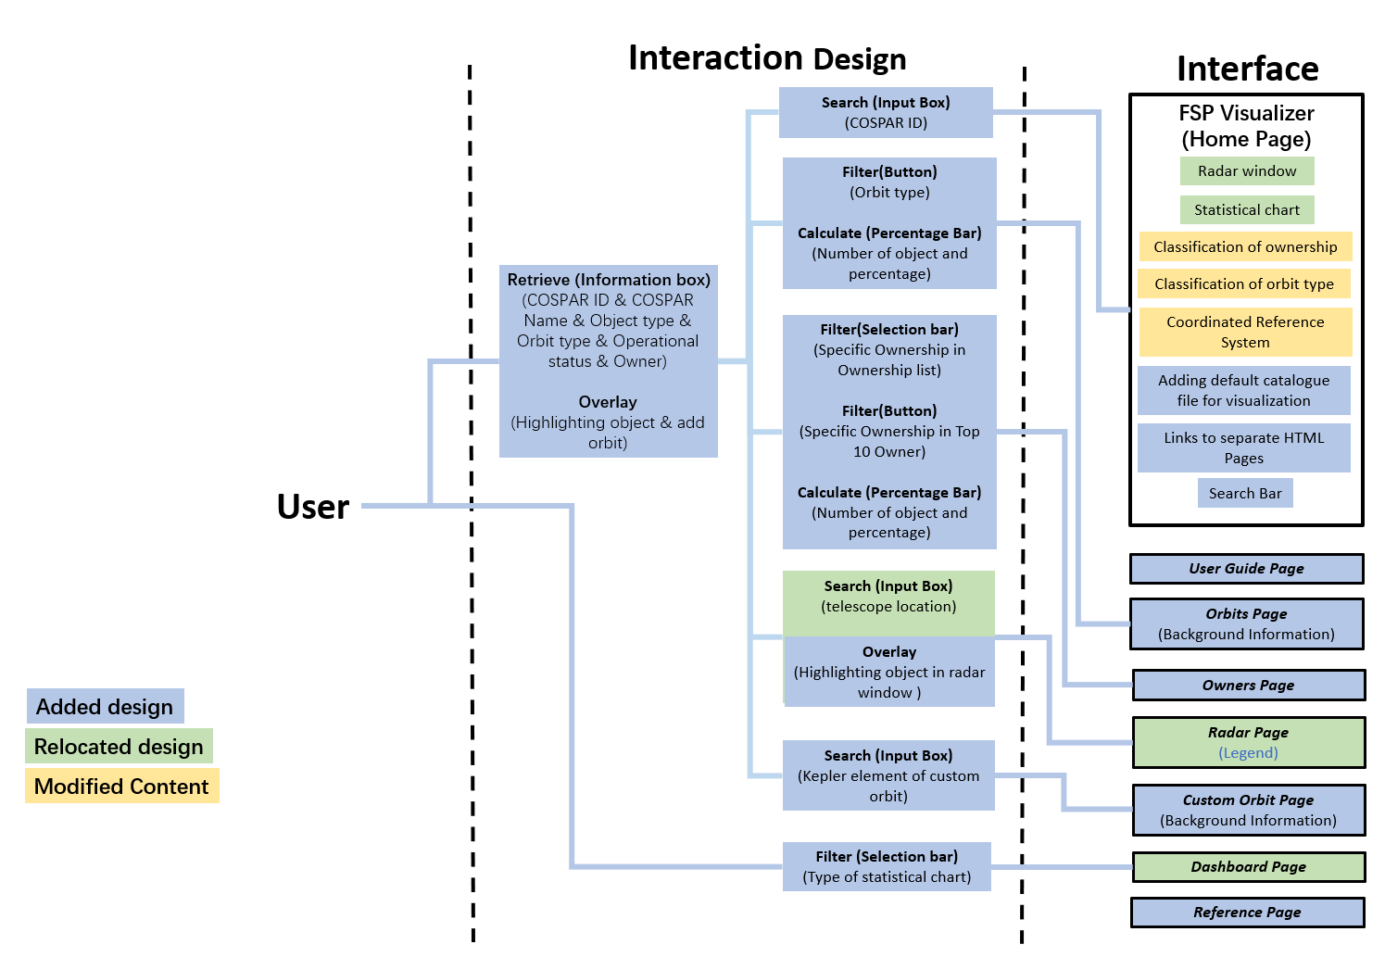

Figure 7. Overview of enhanced designs for FSP visualization of Luyang.

Figure 8-14 display the appearance of each web page in the visualizer, corresponding to the home page (for general information and page switching), the user guide (an instruction page to guide the user), orbits page (for background information on the different types of orbits, statistics and filters), owners page (for ranking and filtering on the number of owners), radar page (for a view of radar stations or objects over a specific location), custom orbits page (for designing and visualizing orbits) , dashboard page (to display 2D statistical charts), and reference page (to allow the user to learn more about the information).

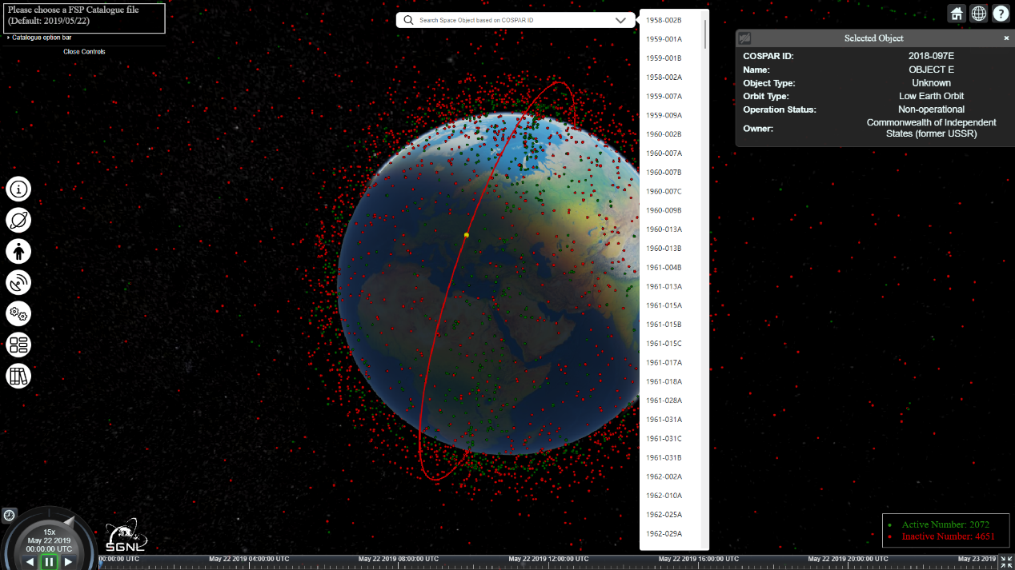

Figure 8. Home page for the FSP Visualizer Alpha version

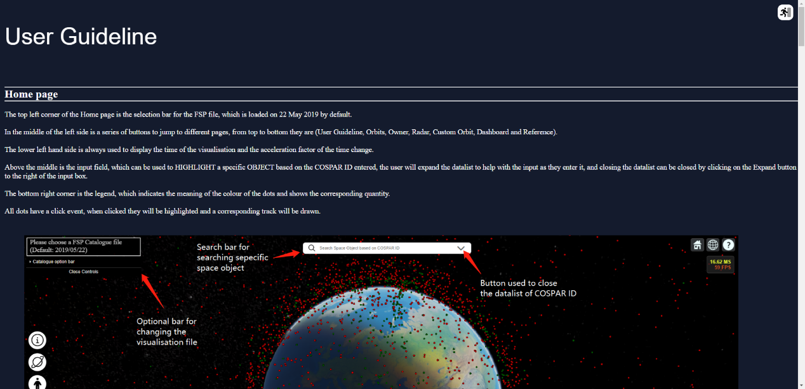

Figure 9. User guide page for the FSP visualizer Alpha version

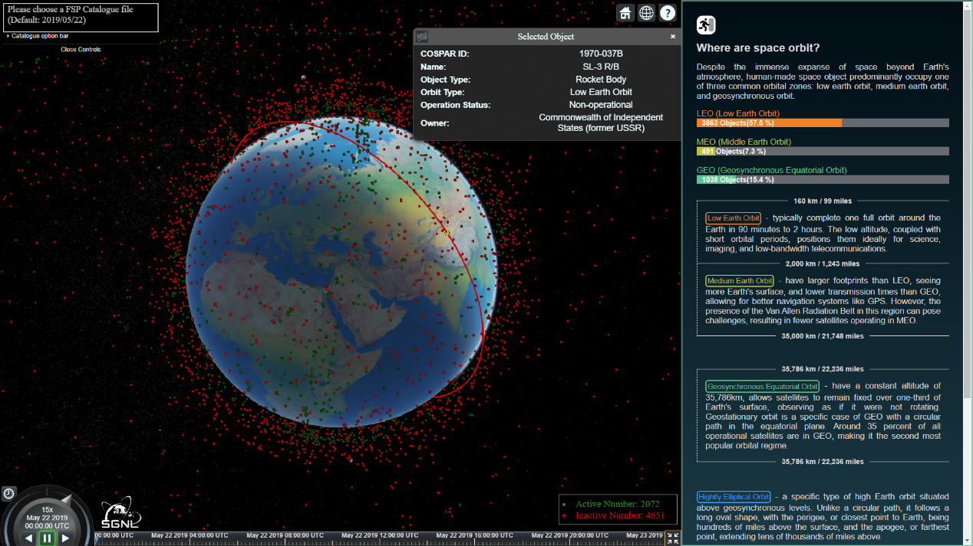

Figure 10. Orbits page for the FSP visualizer Alpha version

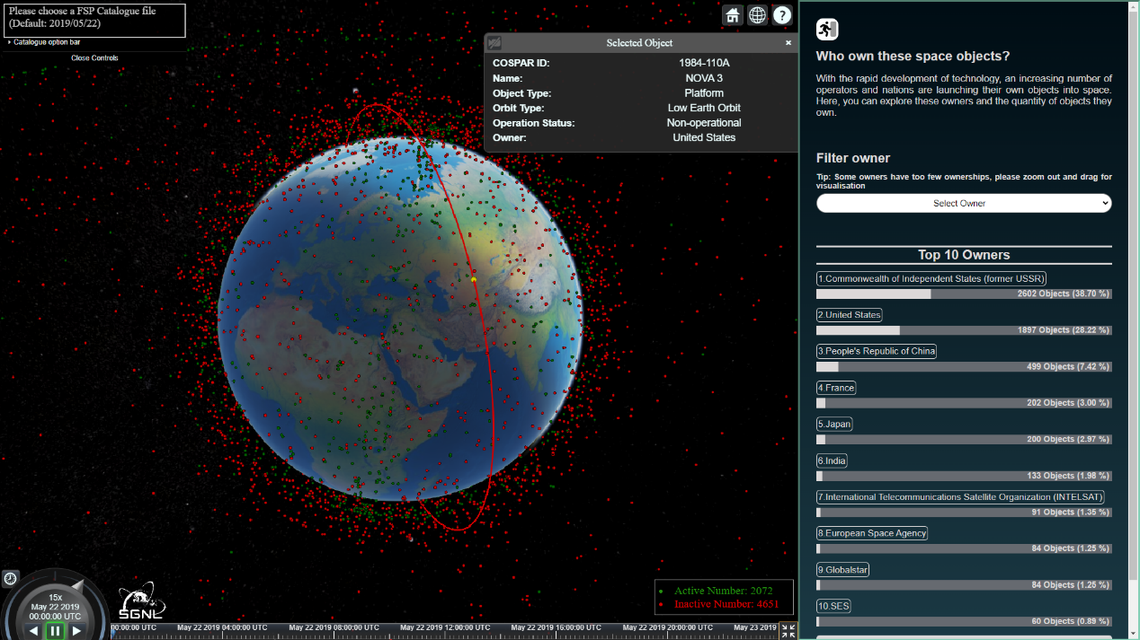

Figure 11. Owner’s page for the FSP visualizer Alpha version

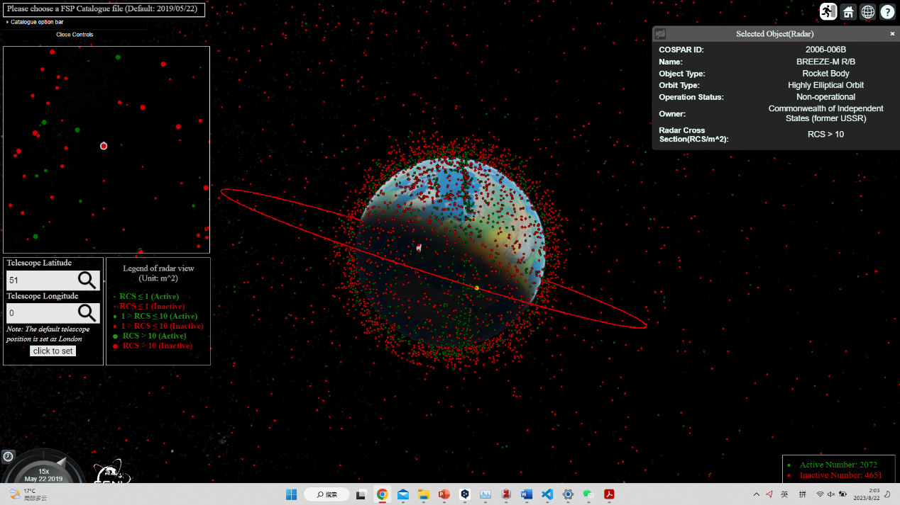

Figure 12. Radar page for the FSP visualizer Alpha version

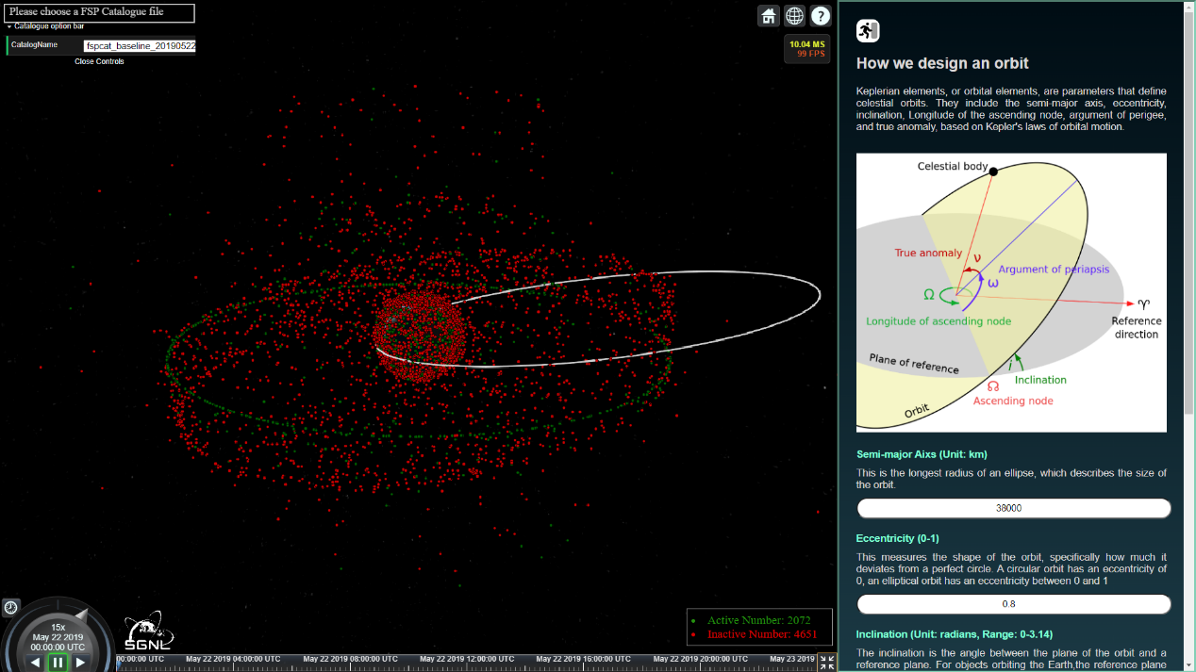

Figure 13. Custom orbit page for the FSP visualizer Alpha version

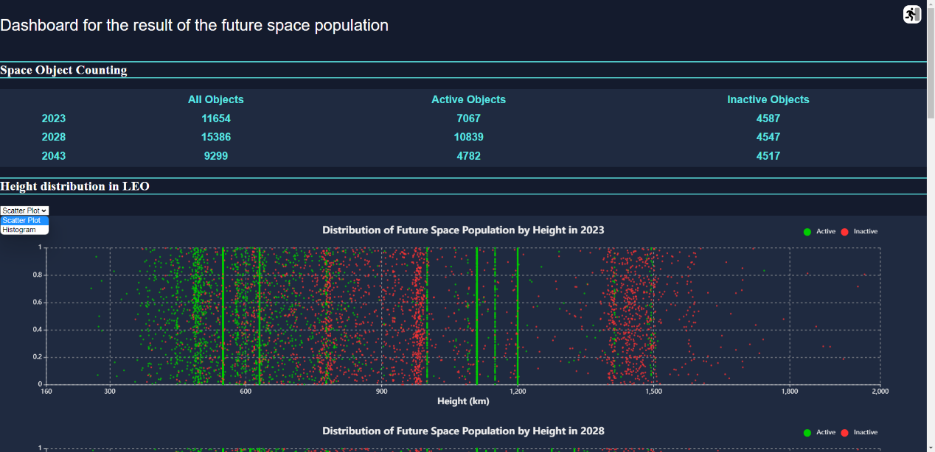

Figure 14. Dashboard page for the FSP visualizer Alpha version

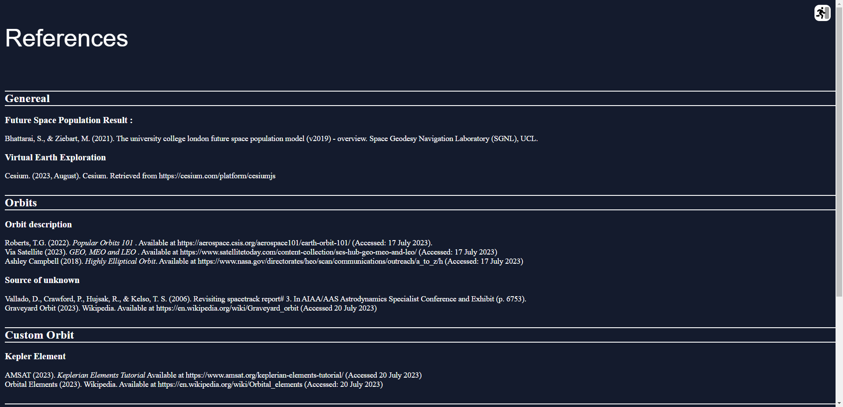

Figure 15. Reference page for the FSP visualizer Alpha version

## Interaction & Usability study results

The outcomes of the interaction and usability study are divided into two sections: usefulness levels and suggestions for future development. Usefulness levels encompass usability and utility, both assigned equal weight following Nielsen's (2012) approach. Suggestions for future improvement, on the other hand, contain suggestions for improvement of existing and future designs. Quantitative results measure the value of the visualizer in terms of usability and utility, whereas qualitative feedback guides enhancement direction and new utility requirements for the beta version (Nielsen, 2012). Scoring of the quantitative questions involves assessing the feedback using a scale of 1 to 5. A score of 3 indicates a neutral response, while a score below 3 indicates negative feedback. Conversely, a rating above 3 indicates a positive response. The degree of positivity or negativity was measured by the magnitude of the rating, i.e., strongly positive (≥4), weakly positive (3-4), neutral (=3), weakly negative (2-3), and strongly negative (≤2).

### Usefulness level

As shown in Figure 16, It can be clearly seen that most of the questions had responses with strong positive feedback, three questions (Q1-5, Q1-20 and Q1-21) presented weak positive feedback and two questions presented weak negative feedback (Q1-1 and Q1-8). Focusing on the less positive feedback, four possible design improvement requirements are identified, which are the method of switching the year of the FSP visualization, customizing the track page, filter buttons in the track page, and errors in the use of the visualizer (Table 7).

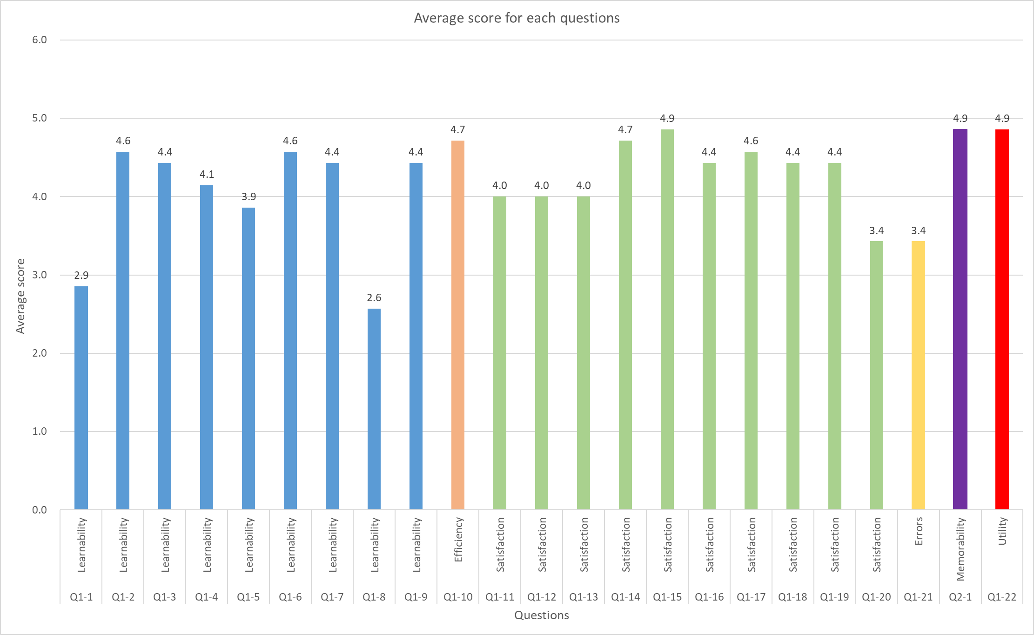

Figure 16. Average score for each quantitative question.

Table 7. Summary of questions where the feedback is not strongly positive

|  |  |  |  |  |
| --- | --- | --- | --- | --- |
| Feedback | Question number | | Detailed question | Related design |
| **Weak negative** | Q1-1 | (On Home Page) How easy is it for you to view the space population for 2023, 2028, and 2043? | | Method of switching the year of the FSP visualization |
| Q1-8 | (Please exit current page and go to Custom Orbit Page) How easy is it for you to create your own orbit on Custom Orbit page? | | Custom orbit page |
| **Weak Positive** | Q1-5 | How easy is it for you to filter the specific type of orbits for visualization in Orbits page? | | Filter buttons in Orbits page |
| Q1-20 | (Please go to the Custom Orbit page) How pleasant is the Custom Orbit design? | | Custom orbit page |
| Q1-21 | Have you encountered any problem or error in the visualizer that are affecting its use? | | Using errors |

With the exception of errors, the average scores for learnability, efficiency, satisfaction, and memorability were all very positive (Figure 17). The final usability score of the Alpha version of the Visualizer was 4.26, indicating that the visualizer is easy to use, but still needs to be improved regarding errors. The utility score of 4.9 indicates that the visualizer is effective in reaching the user's objectives (Figure 16). Therefore, the Alpha version of the Visualizer has a final score of 4.8 for usefulness, making it an ideal and useful visualizer.

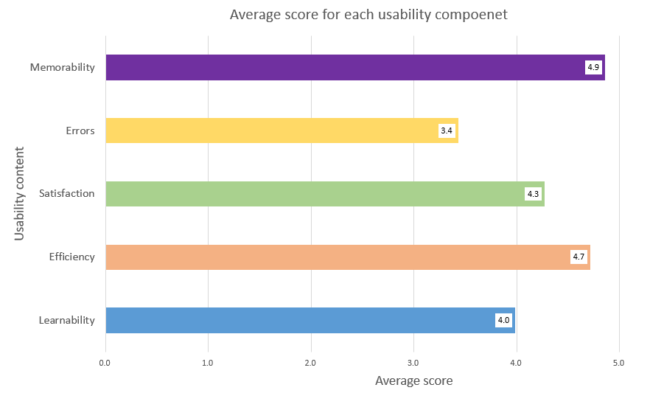

Figure 17．Average score for each usability component

### Suggestions for future improvement

Regarding the open questions at the end of the questionnaire, the seven participants provided a number of valuable suggestions (Figure 8). These suggestions are summarized and outlined below, and the original presentation can be found in the appendix ().

Table 8. Summary of suggestions for future development

|  |
| --- |
| Suggestions for future development |
| A range of values should be added to the semi-major axis in the Custom orbit page. When the semi-major axis is less than the radius of the Earth, the Earth's orbit is drawn inside the Earth, leading the user to think that the orbit cannot be drawn. |
| Buttons should be given interactive capability (e.g. highlighting) so that the user knows whether the button is clickable. |
| Separate layouts and interactions can be set up for different sizes and types of devices to ensure that the web pages work properly on different devices. |
| The timeline can be optimized to include a bolder timeline or to change the timeline style to allow more free time settings. |
| Interactive icons on the left side of the homepage with text descriptions are more user-friendly and convenient. |
| It may be more friendly to represent space objects through other representative icons than through points. |
| The button for returning to the main page can be moved as the page scrolls, so that the user does not have to return to the top or bottom to exit the current page. |
| Before entering the visualizer, give an introduction to the basic background, otherwise the first time you see a bunch of dots around the earth will be confused, even if it is a pop-up window for a brief introduction. |
| The search box could allow for more freely searchable content, not just COSPAR ID. |
| The drop-down list in the search box must be closed by clicking on the drop-down icon, which affects the experience of using it and can be considered for optimization. |
| The names of the visual file catalogues are a bit confusing and take some time to understand, so you can simplify the file names. |
| A custom legend may be a good idea, as users may not just want to visualize active or inactive objects. |

## Beta version

Among the summary of questions where the feedback is not strongly positive () and suggestions on future development

# Appendix

Table 9. Answer of open question on future development

|  |
| --- |
| Suggestions on future development |
| “One error (or no response) spotted from customizing orbit when setting the semi-major axis distance as 3000, eccentricity 0.8. Maybe due to the radius is too small compared with the 6371km average earth radius, along with the high eccentricity of the ellipse, so that this page ends up with overwhelming calculation. Also, web developer could add the human-computer interaction with the click event, in order to show clearly there are some buttons and can be clicked. This can be achieved by adding highlighting colors when the mouse cursor stays on the clickable button. ” |
| “It feels like it's now designed for the compromise of both mouse operation and touch screen operation, and it would be better if the design of the two modes of operation could be separated completely. The timeline interaction can best be operated by an arrow and timeline separately, so that dragging the arrow is to adjust the specific time, and dragging the timeline after zooming can quickly move to a longer span of time, rather than dragging the arrow to make the timeline move quickly.” |
| “All good, my suggestion is to bold the timestamps below the screen. For interactive icons on the left side of the screen, such as User Guide, it is more convenient to display the name directly” |
| "I don't know CesiumJS well enough to understand what his visualisations look like, and I don't have any other CesiumJS project to compare. But if it's possible, I think the overall visualisation could be optimised a bit more and become more appealing. For example, instead of presenting all the satellites as dots (such a dense distribution of red and green dots makes the visualisation experience bad), may be we could replace them with other icons. Also, a text description of each icon could be added to the navigation part on the left of home page, which would be more user-friendly for people who are new to this visualisation tool  However, the overall visualisation is very good." |
| “I think it might be better if the exit button moves alongside as users scroll down the page, otherwise if I'm looking for a specific guide for one certain page ( i.e. custom orbit ), I will have to scroll to the top or the end of the guideline page after getting the information I need. Also, I think you might need to consider adding some introductory content for users that are not so familiar with what you are displaying, for it might be confusing for someone who does not know about orbits to look at a webpage starting with red and greeen dots surrounding the Earth. Maybe even a popup page with a brief introduction will do.” |
| “It will be better if interface could adopt to different size/resolution of screen. As well as the front style & size could be more flexable, not just only Arial. Since I can't find the context which needs to be emphasized well (although it has been highlighted with different colours). Information boxes also overlap each other to somewhere. Furthermore, It may be better if the search bar in the dashboard could search everything that the user wants, instead of only based on the COSPAR ID. Also, the custom orbit page cannot work.” |
| "1. For icons that allow the user to switch pages, it is better to add a description directly rather than displaying the description when the user hovers over the icon.  2. Custom orbits cannot be drawn when the half-length axis is set too small, it is better to give a reasonable range of values in the bracket.  3. The cospar id list displayed in the search bar is well designed, but you need to click on the drop-down icon to close it, otherwise, it stays on the screen and interferes with use.  4. The name of the visualization catalog is a bit confusing and takes some time to understand."  5. A custom legend might be a good idea, as I would like to visualize different information with relative legends for understanding. |

# Reference

Acharya, S. (2021) ‘Interactive cartographic visualization of real-time satellite data and their orbits’, *Abstracts of the ICA*, 3, pp. 1–2. Available at: https://doi.org/10.5194/ica-abs-3-1-2021.

Adjust (2023) *What is a dashboard? Definitions and uses | Adjust*. Available at: https://www.adjust.com/glossary/dashboard/ (Accessed: 21 August 2023).

Amateur Radio In Space (2023) ‘Keplerian Elements Tutorial – AMSAT’. Available at: https://www.amsat.org/keplerian-elements-tutorial/ (Accessed: 10 August 2023).

*BBC News* (2021) ‘Elon Musk rejects claims that his satellites are hogging space’, 30 December. Available at: https://www.bbc.com/news/business-59824404 (Accessed: 10 August 2023).

Bhattarai, S. *et al.* (2019) ‘Demonstrating developments in high-fidelity analytical radiation force modelling methods for spacecraft with a new model for GPS IIR/IIR-M’, *Journal of Geodesy*, 93(9), pp. 1515–1528. Available at: https://doi.org/10.1007/s00190-019-01265-7.

Bhattarai, S. and Ziebart, M. (2021) *The university college london future space population model (v2019) – overview*. Space Geodesy Navigation Laboratory (SGNL), UCL.

Buckley, A. (2012) *Make Maps People Want to Look At*. Available at: https://www.esri.com/news/arcuser/0112/make-maps-people-want-to-look-at.html (Accessed: 13 August 2023).

Campbell, A. (2017) *H is for Highly Elliptical Orbit.*, *NASA*. Available at: http://www.nasa.gov/directorates/heo/scan/communications/outreach/a_to_z/h (Accessed: 10 August 2023).

CelesTrak (2023) *CelesTrak: SATCAT Sources*. Available at: https://celestrak.org/satcat/sources.php (Accessed: 21 August 2023).

Cesium (2023) *About Cesium*, *Cesium*. Available at: https://cesium.com/about/ (Accessed: 15 August 2023).

Chen, C. (2010) ‘Information visualization’, *WIREs Computational Statistics*, 2(4), pp. 387–403. Available at: https://doi.org/10.1002/wics.89.

Chiaro C. (2021) *The Importance of Background Knowledge in Understanding Text*, *TeachHUB*. Available at: https://www.teachhub.com/teaching-strategies/2021/08/the-importance-of-background-knowledge-in-understanding-text/ (Accessed: 21 August 2023).

Cox, L.K. (2021) *Coding for Web Design 101: How HTML, CSS, and JavaScript Work*. Available at: https://blog.hubspot.com/marketing/web-design-html-css-javascript (Accessed: 15 August 2023).

Ebbinghaus H. (2021) ‘The Curve of Forgetting’, *SimonBaddeley64*, 9 June. Available at: https://simonbaddeley64.wordpress.com/2021/06/09/the-curve-of-forgetting/ (Accessed: 21 August 2023).

esri (2023) *Satellite Map | Explore Active Satellites Orbiting Earth*. Available at: https://geoxc-apps.bd.esri.com/space/satellite-explorer/ (Accessed: 18 August 2023).

Faller, P. (2019) ‘What Are User Personas and Why Are They Important? | Adobe XD Ideas’, *Ideas*. Available at: https://xd.adobe.com/ideas/process/user-research/putting-personas-to-work-in-ux-design/ (Accessed: 15 August 2023).

Gabbard, J.L., Hix, D. and Swan, J.E. (1999) ‘User-centered design and evaluation of virtual environments’, *IEEE Computer Graphics and Applications*, 19(6), pp. 51–59. Available at: https://doi.org/10.1109/38.799740.

Graveyard orbit (2023) ‘Graveyard orbit’, *Wikipedia*. Available at: https://en.wikipedia.org/w/index.php?title=Graveyard_orbit&oldid=1162893464 (Accessed: 21 August 2023).

Hix, D. *et al.* (1999) ‘User-centered design and evaluation of a real-time battlefield visualization virtual environment’, in *Proceedings IEEE Virtual Reality (Cat. No. 99CB36316)*. *Proceedings IEEE Virtual Reality (Cat. No. 99CB36316)*, pp. 96–103. Available at: https://doi.org/10.1109/VR.1999.756939.

Holmes, M.W. (2023) ‘Frames of Reference,Orbits and Ellipses’. Available at: https://web.aeromech.usyd.edu.au/AERO2705/2017_course_notes/AERO2705_Wk2_2017_Orbits_Elipses.pdf.

Indigo, B. (2021) *Democratising Data: Future Satellite Populations*. University College London.

Interaction Design Foundation (2023) *What is Information Visualization?*, *The Interaction Design Foundation*. Available at: https://www.interaction-design.org/literature/topics/information-visualization (Accessed: 10 August 2023).

Kopal, V. (1966) ‘Treaty on principles governing the activities of states in the exploration and use of outer space, including the Moon and other celestial bodies’, *YB Air & Space L.*, p. 463.

Leolab (2023) *Low Earth Orbit Visualization | LeoLabs*. Available at: https://platform.leolabs.space/visualization (Accessed: 18 August 2023).

Luyang, H. (2021) *An Enhanced Visualizer for Future Space Population*. University College London.

Muelhaupt, T.J. *et al.* (2019) ‘Space traffic management in the new space era’, *Journal of Space Safety Engineering*, 6(2), pp. 80–87. Available at: https://doi.org/10.1016/j.jsse.2019.05.007.

Netlify (2023) *Develop and deploy websites and apps in record time | Netlify*. Available at: https://www.netlify.com/ (Accessed: 17 August 2023).

NI Business Info (2023) *Advantages of user-centred design | nibusinessinfo.co.uk*. Available at: https://www.nibusinessinfo.co.uk/content/advantages-user-centred-design (Accessed: 16 August 2023).

Nielsen, J. (1992) ‘The usability engineering life cycle’, *Computer*, 25(3), pp. 12–22. Available at: https://doi.org/10.1109/2.121503.

Nielsen, J. (1994) *Usability Engineering*. Morgan Kaufmann.

Nielsen J. (2000) *Why You Only Need to Test with 5 Users*, *Nielsen Norman Group*. Available at: https://www.nngroup.com/articles/why-you-only-need-to-test-with-5-users/ (Accessed: 18 August 2023).

Nielsen, J. (2012) *Usability 101: Introduction to Usability*, *Nielsen Norman Group*. Available at: https://www.nngroup.com/articles/usability-101-introduction-to-usability/ (Accessed: 17 August 2023).

‘Orbital elements’ (2023) *Wikipedia*. Available at: https://en.wikipedia.org/w/index.php?title=Orbital_elements&oldid=1155075030 (Accessed: 10 August 2023).

Ordnance Survey (2022) *What is Cartography? | Blog*, *Ordnance Survey*. Available at: https://www.ordnancesurvey.co.uk/blog/what-is-cartography (Accessed: 13 August 2023).

Our World In Data (2023) *Annual number of objects launched into space*, *Our World in Data*. Available at: https://ourworldindata.org/grapher/yearly-number-of-objects-launched-into-outer-space (Accessed: 10 August 2023).

Peterson, G., Sorge, M. and Ailor, W. (2018) ‘Space traffic management in the age of new space’, *Center for Space Policy and Strategy, the Aerospace Corporation. Accessed on*, pp. 2018–05.

Pickover, C. (2008) *Archimedes to Hawking: laws of science and the great minds behind them*. Oxford University Press.

Rizzi, G. and Ruggiero, M.L. (2003) *Relativity in Rotating Frames: Relativistic Physics in Rotating Reference Frames*. Springer Science & Business Media.

Roberts, T.G. (2017) *Popular Orbits 101*, *Aerospace Security*. Available at: https://aerospace.csis.org/aerospace101/earth-orbit-101/ (Accessed: 10 August 2023).

Robinson, A.C. *et al.* (2005) ‘Combining Usability Techniques to Design Geovisualization Tools for Epidemiology’, *Cartography and Geographic Information Science*, 32(4), pp. 243–255. Available at: https://doi.org/10.1559/152304005775194700.

Robinson, A.C., MacEachren, A.M. and Roth, R.E. (2011) ‘Designing a web-based learning portal for geographic visualization and analysis in public health’, *Health Informatics Journal*, 17(3), pp. 191–208. Available at: https://doi.org/10.1177/1460458211409718.

Robinson, A.H. *et al.* (1995) *Elements of cartography. 6th ed*. 6th edn. New York, N.Y.: John Wiley & Sons.

Rosson, M.B. and Carroll, J.M. (2002) ‘Scenario-based usability engineering’, in *Proceedings of the 4th conference on Designing interactive systems: processes, practices, methods, and techniques*. New York, NY, USA: Association for Computing Machinery (DIS ’02), p. 413. Available at: https://doi.org/10.1145/778712.778776.

Roth, R.E. (2012) ‘Cartographic Interaction Primitives: Framework and Synthesis’, *The Cartographic Journal*, 49(4), pp. 376–395. Available at: https://doi.org/10.1179/1743277412Y.0000000019.

Roth, R.E. (2013a) ‘An Empirically-Derived Taxonomy of Interaction Primitives for Interactive Cartography and Geovisualization’, *IEEE Transactions on Visualization and Computer Graphics*, 19(12), pp. 2356–2365. Available at: https://doi.org/10.1109/TVCG.2013.130.

Roth, R.E. (2013b) ‘Interactive maps: What we know and what we need to know’, *Journal of Spatial Information Science*, (6), pp. 59–115.

Roth, R.E., Ross, K.S. and MacEachren, A.M. (2015) ‘User-Centered Design for Interactive Maps: A Case Study in Crime Analysis’, *ISPRS International Journal of Geo-Information*, 4(1), pp. 262–301. Available at: https://doi.org/10.3390/ijgi4010262.

Satvis.space (2023) *Satellite Orbit Visualization*. Available at: https://satvis.space/ (Accessed: 18 August 2023).

Scott W. (2019) *Preserving the space environment for future generations*, *Maxar Blog*. Available at: https://blog.maxar.com/tech-and-tradecraft/2019/preserving-the-space-environment-for-future-generations (Accessed: 11 August 2023).

Slocum, T.A. *et al.* (2003) ‘Evaluating the Usability of a Tool for Visualizing the Uncertainty of the Future Global Water Balance’, *Cartography and Geographic Information Science*, 30(4), pp. 299–317. Available at: https://doi.org/10.1559/152304003322606210.

SourceForge (2023) *Cesium*, *SourceForge*. Available at: https://sourceforge.net/projects/cesium.mirror/ (Accessed: 15 August 2023).

SpaceAware.io (2023) *SpaceAware.io*. Available at: https://spaceaware.io/ (Accessed: 18 August 2023).

SpatialPost (2021) ‘Legend On A Map: Symbols Explained & How They Affect Your Maps | Spatial Post’, 30 September. Available at: https://www.spatialpost.com/legend-on-a-map/ (Accessed: 21 August 2023).

Szyndlar M. (2023) *How to Create an Anonymous Survey (And Why You Should Do It)*. Available at: https://survicate.com/blog/anonymous-survey/ (Accessed: 18 August 2023).

The European Space Agency (2020) *Types of orbits*. Available at: https://www.esa.int/Enabling_Support/Space_Transportation/Types_of_orbits (Accessed: 10 August 2023).

The United States Government (2019) *The United States Government Orbital Debris Mitigation Standard Practices (2019)*. Available at: https://orbitaldebris.jsc.nasa.gov/library/usg_orbital_debris_mitigation_standard_practices_november_2019.pdf (Accessed: 10 August 2023).

Truchly, P. and Cervienka, J. (2016) ‘Simple visualization tool for analysis of satellite orbits and constellations’, in *2016 International Conference on Emerging eLearning Technologies and Applications (ICETA)*. *2016 International Conference on Emerging eLearning Technologies and Applications (ICETA)*, pp. 359–364. Available at: https://doi.org/10.1109/ICETA.2016.7802101.

Tsou, M.-H. and Curran, J.M. (2008) ‘User-Centered Design Approaches for Web Mapping Applications: A Case Study with USGS Hydrological Data in the United States’, in M.P. Peterson (ed.) *International Perspectives on Maps and the Internet*. Berlin, Heidelberg: Springer Berlin Heidelberg (Lecture Notes in Geoinformation and Cartography), pp. 301–321. Available at: https://doi.org/10.1007/978-3-540-72029-4_20.

Vallado, D. *et al.* (2006) ‘Revisiting Spacetrack Report #3’, in *AIAA/AAS Astrodynamics Specialist Conference and Exhibit*. American Institute of Aeronautics and Astronautics (Guidance, Navigation, and Control and Co-located Conferences). Available at: https://doi.org/10.2514/6.2006-6753.

Via Satellite (2021) *GEO, MEO, and LEO*, *Via Satellite*. Available at: https://www.satellitetoday.com/content-collection/ses-hub-geo-meo-and-leo/ (Accessed: 10 August 2023).

Vredenburg, K. *et al.* (2002) ‘A Survey of User-Centered Design Practice’, (1).

Zerlinda (2019) ‘User Centered Design — Persona’, *Moodah POS*, 26 December. Available at: https://medium.com/moodah-pos/user-centered-design-persona-5cce0dce0833 (Accessed: 15 August 2023).

ZURICH (2022) *Space congestion: An increasingly contested and crowded frontier*. Available at: https://www.zurich.com/en/media/magazine/2022/from-moonshot-to-musk-how-the-rules-of-the-game-are-changing-in-space (Accessed: 10 August 2023).